1.Add 2 numbers

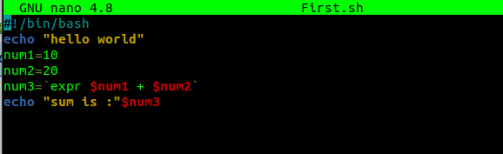

output

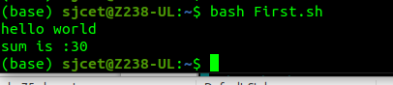

2.Swap two values

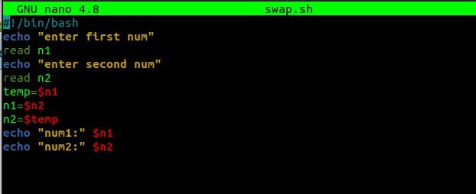

output

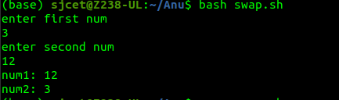

3. pgm to print n numbers

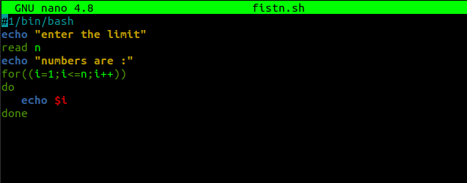

output

